Easy Gourmet Chocolate Chip

Description
A generous amount of chocolate chips in a “just like homemade” cookie dough. 2.5lb (36 - Easy individual, ready to bake 1.1oz pucks)
Ingredients
INGREDIENTS: ENRICHED WHEAT FLOUR [WHEAT FLOUR, NIACIN, REDUCED IRON, THIAMINE MONONITRATE, RIBOFLAVIN, FOLIC ACID], MARGARINE [VEGETABLE OIL BLEND (PALM OIL AND SOYBEAN OIL), WATER, SALT, CONTAINS LESS THAN 2% SOY LECITHIN, VEGETABLE MONO AND DIGLYCERIDES, CITRIC ACID, NATURAL AND ARTIFICIAL FLAVOR, BETA CAROTENE (COLOR), VITAMIN A PALMITATE, WHEY], SUGAR, BROWN SUGAR, SEMI-SWEET CHOCOLATE DROPS [SUGAR, CHOCOLATE LIQUOR, COCOA BUTTER, DEXTROSE, SOY LECITHIN (EMULSIFIER), ARTIFICIAL FLAVOR], EGGS, INVERT SYRUP, SODIUM BICARBONATE, ARTIFICIAL FLAVORS, SALT.
Allergens
CONTAINS: WHEAT, EGGS, SOY & MILK MAY CONTAIN TREE NUTS & PEANUTS

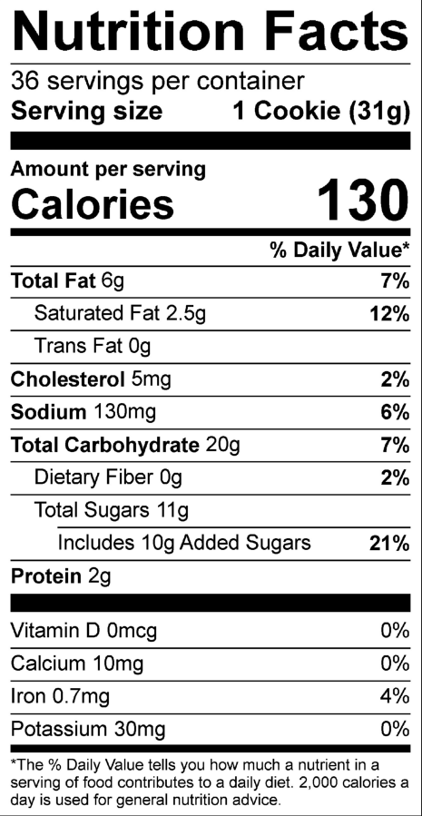

Easy Gourmet White Choc Cranberry

Description
We blend white chocolate chips and cranberries to make a soft, chewy cookie! 2.5lb (36 - Easy individual, ready to bake 1.1oz pucks)
Ingredients
INGREDIENTS: ENRICHED WHEAT FLOUR [WHEAT FLOUR, NIACIN, REDUCED IRON, THIAMINE MONONITRATE, RIBOFLAVIN, FOLIC ACID], MARGARINE [VEGETABLE OIL BLEND (PALM OIL AND SOYBEAN OIL), WATER, SALT, CONTAINS LESS THAN 2% SOY LECITHIN, VEGETABLE MONO AND DIGLYCERIDES, CITRIC ACID, NATURAL AND ARTIFICIAL FLAVOR, BETA CAROTENE (COLOR), VITAMIN A PALMITATE, WHEY], SUGAR, BROWN SUGAR, WHITE CONFECTIONER'S DROPS [SUGAR, NONFAT MILK POWDER, HYDROGENATED PALM KERNEL OIL, SOY LECITHIN (EMULSIFIER), MONOGLYCERIDES, ARTIFICIAL COLOR (TITANIUM DIOXIDE), ARTIFICIAL FLAVOR], EGGS, SWEETENED DRIED CRANBERRIES [CRANBERRIES, SUGAR, SUNFLOWER OIL], INVERT SYRUP, SODIUM BICARBONATE, ARTIFICIAL FLAVORS, SALT.
Allergens
CONTAINS: WHEAT, EGGS, SOY, & MILK. MAY CONTAIN TREE NUTS & PEANUTS.

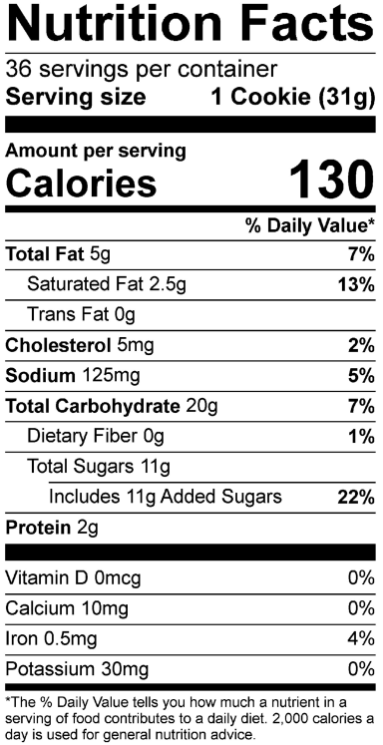

Easy Gourmet Triple Fudge

Description
A delicious blend of rich chocolate dotted with white chocolate chips. 2.5lb (36 - Easy individual, ready to bake 1.1oz pucks)
Ingredients
INGREDIENTS: ENRICHED WHEAT FLOUR [WHEAT FLOUR, NIACIN, REDUCED IRON, THIAMINE MONONITRATE, RIBOFLAVIN, FOLIC ACID], MARGARINE [VEGETABLE OIL BLEND (PALM OIL AND SOYBEAN OIL), WATER, SALT, CONTAINS LESS THAN 2% SOY LECITHIN, VEGETABLE MONO AND DIGLYCERIDES, CITRIC ACID, NATURAL AND ARTIFICIAL FLAVOR, BETA CAROTENE (COLOR), VITAMIN A PALMITATE, WHEY], SUGAR, BROWN SUGAR, WHITE CONFECTIONER'S DROPS [SUGAR, NONFAT MILK POWDER, HYDROGENATED PALM KERNEL OIL, SOY LECITHIN (EMULSIFIER), MONOGLYCERIDES, ARTIFICIAL COLOR (TITANIUM DIOXIDE), ARTIFICIAL FLAVOR], COCOA PROCESSED WITH ALKALI, EGGS, SEMI-SWEET CHOCOLATE DROPS [SUGAR, CHOCOLATE LIQUOR, COCOA BUTTER, DEXTROSE, SOY LECITHIN (EMULSIFIER), ARTIFICIAL FLAVOR], INVERT SYRUP, SODIUM BICARBONATE, SALT, ARTIFICIAL FLAVORS.
Allergens
CONTAINS: WHEAT, EGGS, SOY, & MILK. MAY CONTAIN TREE NUTS & PEANUTS.

Easy Gourmet Candy

Description
Children will love these cookies loaded with colorful candy coated chocolates. 2.5lb (36 - Easy individual, ready to eat 1.1oz pucks)
Ingredients
INGREDIENTS: ENRICHED WHEAT FLOUR [WHEAT FLOUR, NIACIN, REDUCED IRON, THIAMINE MONONITRATE, RIBOFLAVIN, FOLIC ACID], MARGARINE [VEGETABLE OIL BLEND (PALM OIL AND SOYBEAN OIL), WATER, SALT, CONTAINS LESS THAN 2% SOY LECITHIN, VEGETABLE MONO AND DIGLYCERIDES, CITRIC ACID, NATURAL AND ARTIFICIAL FLAVOR, BETA CAROTENE (COLOR), VITAMIN A PALMITATE, WHEY], SUGAR, BROWN SUGAR, MILK CHOCOLATE POKIES [MILK CHOCOLATE (SUGAR, COCOA BUTTER, CHOCOLATE LIQUOR, WHOLE MILK POWDER, SOY LECITHIN {EMULSIFIER}, VANILLA), SUGAR, ARTIFICIAL COLOR (BLUE 1, BLUE 1 LAKE, BLUE 2 LAKE, YELLOW 5, YELLOW 5 LAKE, YELLOW 6, YELLOW 6 LAKE, RED 40, RED 40 LAKE, SORBITOL, TITANIUM DIOXIDE, PHOSPHORIC ACID, METHYL AND PROPYL PARABENS, CARAMEL), CORN SYRUP, WAX, DEXTRIN], EGGS, INVERT SYRUP, SODIUM BICARBONATE, ARTIFICIAL FLAVORS, SALT.
Allergens
CONTAINS: WHEAT, EGGS, SOY, & MILK MAY CONTAIN TREE NUTS & PEANUTS

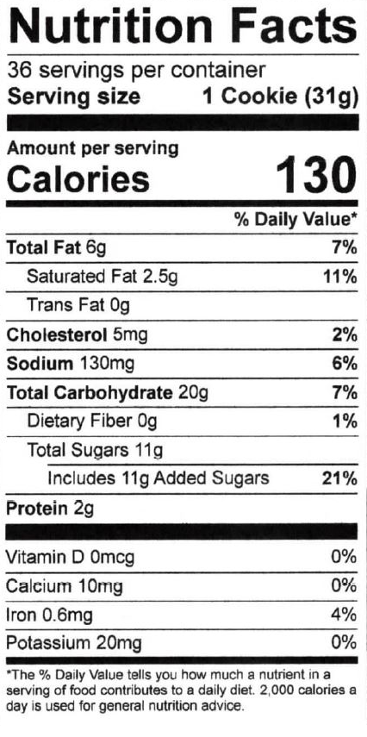

Easy Gourmet White Mac Nut

Description
White chocolate chips and yummy macadamia nuts adorn these tasty cookies. 2.5lb (36 - Easy individual, ready to eat 1.1oz pucks)
Ingredients
INGREDIENTS: ENRICHED WHEAT FLOUR [WHEAT FLOUR, NIACIN, REDUCED IRON, THIAMINE MONONITRATE, RIBOFLAVIN, FOLIC ACID], MARGARINE [VEGETABLE OIL BLEND (PALM OIL AND SOYBEAN OIL), WATER, SALT, CONTAINS LESS THAN 2% SOY LECITHIN, VEGETABLE MONO AND DIGLYCERIDES, CITRIC ACID, NATURAL AND ARTIFICIAL FLAVOR, BETA CAROTENE (COLOR), VITAMIN A PALMITATE, WHEY], SUGAR, BROWN SUGAR, WHITE CONFECTIONER'S DROPS [SUGAR, NONFAT MILK POWDER, HYDROGENATED PALM KERNEL OIL, SOY LECITHIN (EMULSIFIER), MONOGLYCERIDES, ARTIFICIAL COLOR (TITANIUM DIOXIDE), ARTIFICIAL FLAVOR], EGGS, MACADAMIA NUTS, INVERT SYRUP, SODIUM BICARBONATE, ARTIFICIAL FLAVORS, SALT
Allergens
CONTAINS: WHEAT, EGGS, SOY, MILK, & TREE NUT (MACADAMIA).. MAY CONTAIN TREE NUTS & PEANUTS.

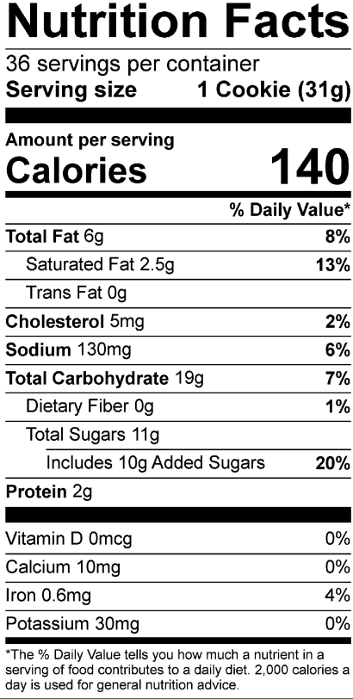

Easy Gourmet Peanut Butter Cup

Description
Chocolate covered peanut butter cups mixed in our delicious dough. Caution: These are habit forming! 2.5lb (36 - Easy individual, ready to bake 1.1oz pucks)
Ingredients
INGREDIENTS: ENRICHED WHEAT FLOUR [WHEAT FLOUR, NIACIN, REDUCED IRON, THIAMINE MONONITRATE, RIBOFLAVIN, FOLIC ACID], SUGAR, MARGARINE [VEGETABLE OIL BLEND (PALM OIL AND SOYBEAN OIL), WATER, SALT, CONTAINS LESS THAN 2% SOY LECITHIN, VEGETABLE MONO AND DIGLYCERIDES, CITRIC ACID, NATURAL AND ARTIFICIAL FLAVOR, BETA CAROTENE (COLOR), VITAMIN A PALMITATE, WHEY], MILK CHOCOLATE PEANUT BUTTER MINI CUPS [MILK CHOCOLATE (SUGAR, COCOA BUTTER, CHOCOLATE, WHOLE MILK POWDER, SOY LECITHIN, VANILLA), PEANUT BUTTER (PEANUTS, HYDROGENATED VEGETABLE OIL {RAPESEED AND/OR COTTONSEED}, SALT), HYDROGENATED PALM KERNEL OIL, POWDERED SUGAR (SUGAR, CORN STARCH), DEXTROSE, SALT, PEANUT OIL], EGGS, INVERT SYRUP, SODIUM BICARBONATE, ARTIFICIAL FLAVORS, SALT.
Allergens
CONTAINS: WHEAT, EGGS, SOY, MILK & PEANUTS. MAY CONTAIN TREE NUTS & PEANUTS

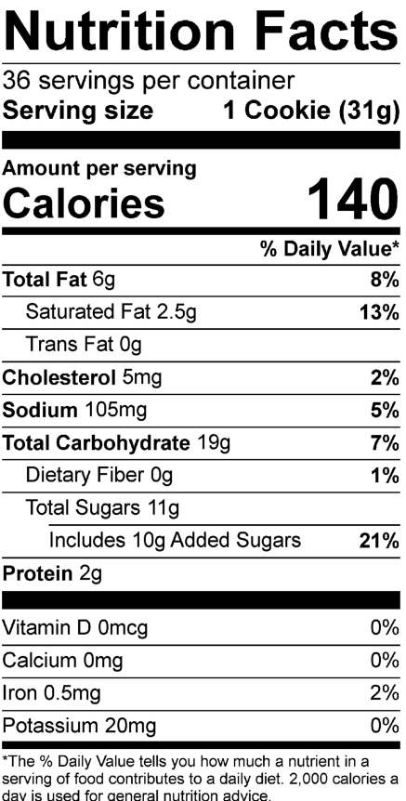

Easy Gourmet Milk Chocolate Pecan

Description
Rich milk chocolate chips and pecan pieces load up our flavorful cookie dough. 2.5lb (36 - Easy individual, ready to eat 1.1oz pucks)
Ingredients
INGREDIENTS: ENRICHED WHEAT FLOUR [WHEAT FLOUR, NIACIN, REDUCED IRON, THIAMINE MONONITRATE, RIBOFLAVIN, FOLIC ACID], MARGARINE [VEGETABLE OIL BLEND (PALM OIL AND SOYBEAN OIL), WATER, SALT, CONTAINS LESS THAN 2% SOY LECITHIN, VEGETABLE MONO AND DIGLYCERIDES, CITRIC ACID, NATURAL AND ARTIFICIAL FLAVOR, BETA CAROTENE (COLOR), VITAMIN A PALMITATE, WHEY], SUGAR, BROWN SUGAR, MILK CHOCOLATE DROPS [SUGAR, COCOA BUTTER, WHOLE MILK, CHOCOLATE LIQUOR, SOY LECITHIN (EMULSIFIER), ARTIFICIAL FLAVOR], EGGS, PECANS [PECANS, COTTONSEED OIL, SALT], INVERT SYRUP, SODIUM BICARBONATE, ARTIFICIAL FLAVORS, SALT.
Allergens
CONTAINS: WHEAT, EGGS, SOY, MILK & TREENUT (PECANS). MAY CONTAIN TREE NUTS & PEANUTS
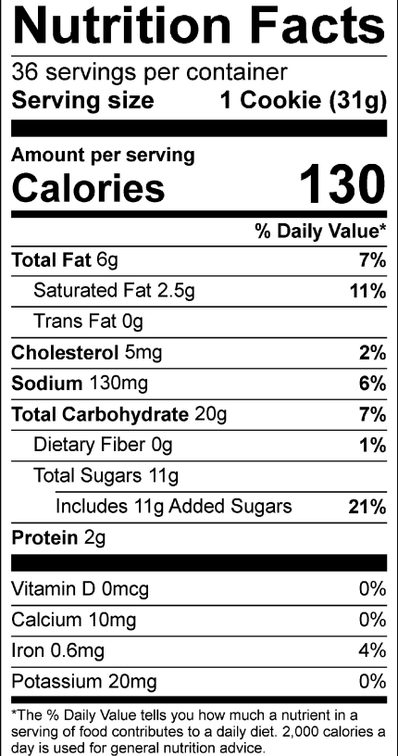

Easy Gourmet Snickerdoodle

Description
Reminisce about Grandma’s warm cinnamon and sugar cookies. 2.5lb (36 - Easy individual, ready to eat 1.1oz pucks)
Ingredients
Enriched Wheat Flour (bleached wheat flour, malted barley flour, niacin, reduced iron, thiamine mononitrate, riboflavin, folic acid), Sugar, Butter Blend (liquid and partially hydrogenated soybean oil, skim milk, butter [cream, salt], natural flavor, vitamin A palmitate, beta carotene [color], soy lecithin, salt), Palm Oil Margarine (palm oil, water, soybean oil, salt, vegetable mono & diglycerides, soy lecithin, sodium benzoate [preservative], citric acid, natural and artificial flavor, beta carotene [color], vitamin A palmitate, whey), Whole Eggs (eggs, citric acid, water), Liquid Sugar (granulated sugar, water), Cinnamon, Baking Soda, Artificial Vanilla Flavor, Salt.
Allergens
Contains: Egg, Milk, Soy, & Wheat. May contain treenuts and peanuts.

