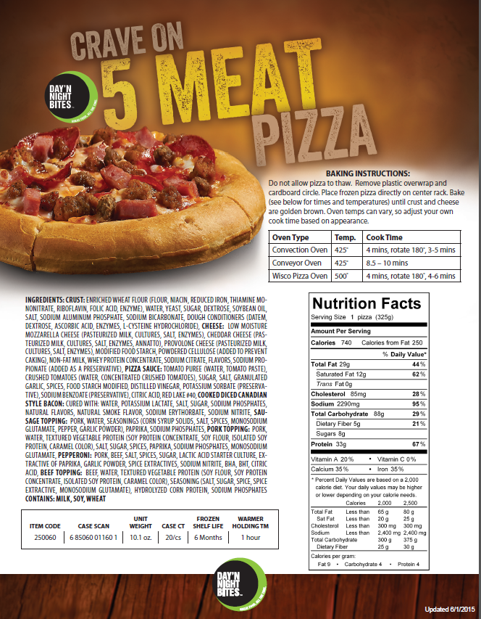

BREAKFAST PIZZA
INGREDIENTS: CRUST: WHEAT FLOUR, WATER, YEAST, SOYBEAN OIL, DEXTROSE, SALT, BAKING POWDER (STARCH, SODIUM ALUMINUM PHOSPHATE, SODIUM BICARBONATE), DOUGH CONDITIONER (FLOUR, CALCIUM SULFATE, SALT, L-CYSTEINE, FUNGAL PROTEASE, FUNGAL AMYLASE, SORBIC ACID), CHEESE: LOW MOISTURE MOZZARELLA CHEESE (PASTEURIZED MILK, SKIM MILK, CULTURES, SALT, ENZYMES), CHEDDAR CHEESE (PASTEURIZED MILK, CULTURES, SALT, ENZYMES, ANNATTO), PROVOLONE CHEESE (PASTEURIZED MILK, CULTURES, SALT, ENZYMES), MODIFIED FOOD STARCH, POWDERED CELLULOSE (ADDED TO PREVENT CAKING), NONFAT MILK, WHEY PROTEIN CONCENTRATE, SODIUM CITRATE, FLAVORS, SODIUM PROPIONATE (ADDED AS A PRESERVATIVE), CHEESE SAUCE: CHEESE WHEY, WATER, PALM OIL, MODIFIED CORN STARCH, MODIFIED TAPIOCA STARCH, LESS THAN 2% OF: CHEDDAR CHEESE (MILK, CULTURES, SALT AND ENZYMES), MALTODEXTRIN, SALT, SODIUM PHOSPHATE, SODIUM CITRATE, VINEGAR, SODIUM STEAROYL LACTYLATE, MONO & DIGLYCERIDES, ANNATTO COLOR, DISODIUM INOSINATE, FD&C YELLOW 6, PORK TOPPING: PORK, WATER, TEXTURED VEGETABLE PROTEIN (SOY PROTEIN CONCENTRATE, SOY FLOUR, ISOLATED SOY PROTEIN, CARAMEL COLOR), SALT, SUGAR, SPICES, PAPRIKA, SODIUM PHOSPHATES, MONOSODIUM GLUTAMATE, SCRAMBLED EGGS: WHOLE EGGS, SKIM MILK, SOYBEAN OIL, CORN STARCH, SALT, XANTHAN GUM, CITRIC ACID, BACON PIECES: BACON (CURED WITH WATER, SALT, SUGAR, SODIUM NITRITE. MAY ALSO CONTAIN SMOKE FLAVORING, DEXTROSE, SODIUM PHOSPHATES, SODIUM ERYTHORBATE, SODIUM ASCORBATE, FLAVORING). CONTAINS: EGG, MILK, SOY, WHEAT

